**DISCOVERING OUTLOOK GROUPS – OUTLOOK DESKTOP**

At Company, we have many groups used for Collaboration through SharePoint, Teams, and Outlook.

If you are an owner or member of one or more of these groups, the group “should” appear in your Outlook mailbox, under the inbox folders. If you do not see the group mailboxes, you can also “Discover” them, using the steps below:

### **Search for a group to join**

1. On the **Home** tab, select **Browse Groups**.



**Note:** If you do not have the option of **Browse Groups**, please look for **Discover Groups**. The Outlook new experience offers that option:

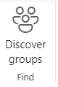

**Note:** The outlook new experience can be turned on here: 

1. Enter a group name in the search box or scroll the list to find the one you want.
2. Click **Join**.

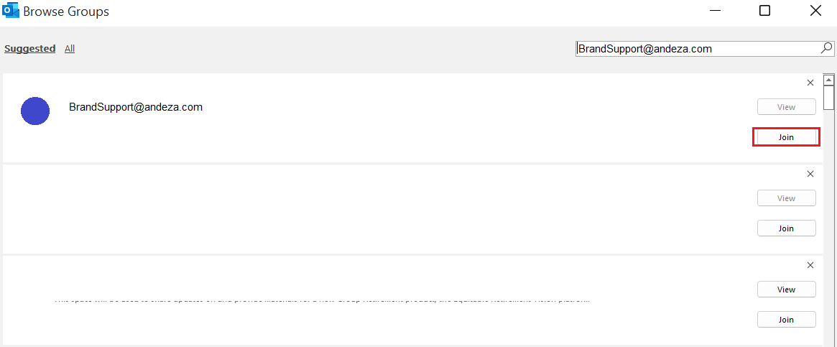

1. If the group is private, a request will be sent to the group's admin, who can accept or decline the request.